Key Stage 3 French Homework Guide
French homework will be set fortnightly, on Monday of week 1. It will need to be completed online by 9am on the following Monday week 1 (2 weeks later). Instructions for how to complete it are below:
- Log into the Sentence Builders website (www.sentencebuilders.com) with your username and 4 digit password which you will have been given by your French teacher.
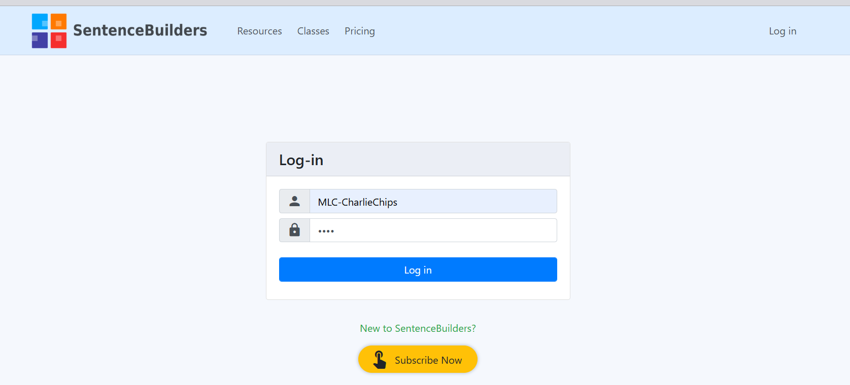

- Once logged on, you will be able to see any assignments that have been set. Click on the yellow ‘Start’ button to start the assignment.
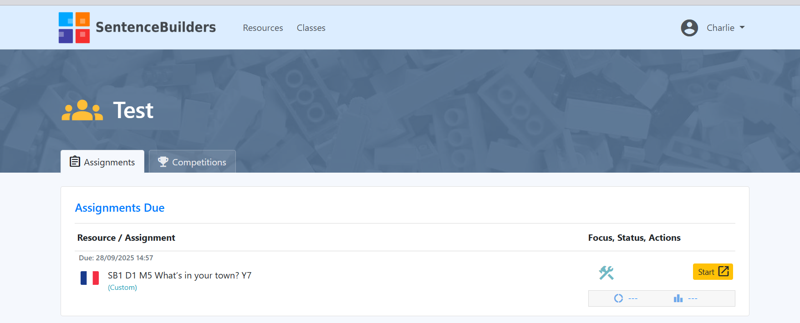
- Once you’ve clicked start, you can then start playing the games, just like we do in class.
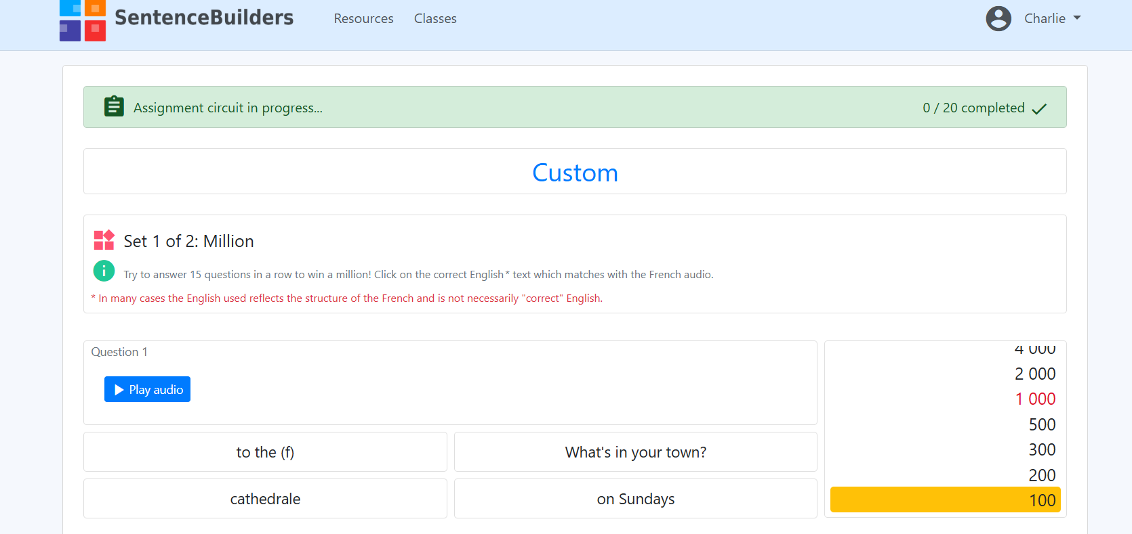
- If you need help, click on the tab that says ‘Sentence builder view’ to see the sentence builder. You can also click on the French words to hear how they are pronounced.
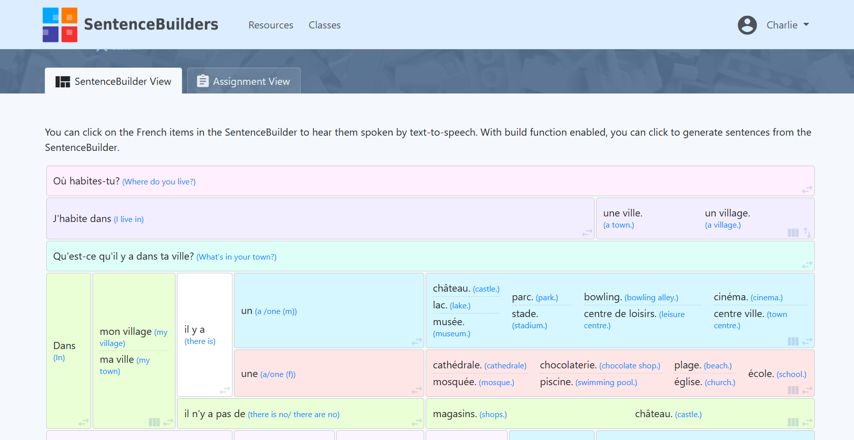
- Once you have completed each game, a pop-up message will appear, telling you your score and giving you the option to repeat the game if you want to. If not, click ok and it will take you to the next game.
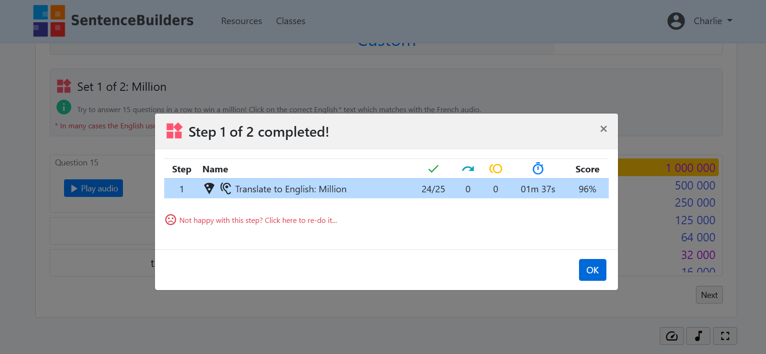
- Once all the steps are complete, the assignment will show as completed on your login screen. If you’d like to redo it (to improve your score) click on the green arrow next to the box with the tick in.
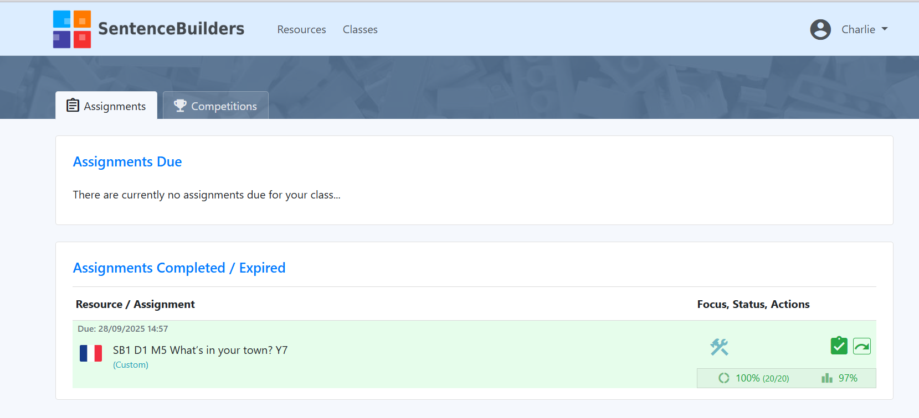
Once you have completed the assignment, you will need to go back to Google classroom to mark it as completed. All students who complete their homework will be awarded Voice points. If you have a genuine reason for not being able to do your homework, please let your teacher know before the deadline.

